College Database Management System (DBMS)

UDDIT

Abstract- College Data Management System gives a straightforward interface to support of understudy data, staff information,attendance,fee record. It very well may be utilized by instructive establishments or schools to keep up the records of understudies without any problem. The creation and the executives of exact, modern data with respect to an understudies' scholastic profession is fundamentally significant in the college just as universities. Understudy data framework manages all sort of understudy subtleties, scholarly related reports, school subtleties, course subtleties, educational program, cluster subtleties, position subtleties and other asset related subtleties as well. It will likewise have workforce subtleties, clump execution subtleties, understudies' subtleties in all perspectives, the different scholastic notices to the staff and understudies refreshed by the school organization. The client can updadte stuent,staff records eliminate them effectively through the administrator.

Keyword: Student, Admin, Staff

INTRODUCTION

The plan and execution of an exhaustive College Data Management System and UI is to supplant the current paper records. School Staff can straightforwardly get to all parts of an understudy's scholarly advancement through a safe, online interface implanted in the school's site. The framework uses client verification, showing just data vital for a person's obligations. Furthermore, each sub-framework has verification permitting approved clients to make or refresh data in that subsystem.. The framework includes an unpredictable logging framework ,
When the admin logins through he has the complete control of the System whether it would be of staff or understudy. Disconnected frameworks by and large don't need the utilization of any intricate segments. To keep up the record of universities, understudies, assessment and result, the school the board framework readies the record for every office, demonstrating the all out number of schools and understudies. It additionally monitors any adjustment vital related to students and colleges, and produces regular reports for the organization giving the total information required.

File Handling
Files area used to store knowledge during a memory device for good. File handling provides a mechanism to store the output of a program during a file and to perform numerous operations on that. A stream is Associate in Nursing abstraction that represents a tool on that operations of input and output area unit performed. A stream will be pictured as a supply or destination of characters of indefinite length looking on its usage.
These embody ifstream, ofstream, and fstream. These categories area unit derived from fstrembase and from the corresponding iostream category. These categories, designed to manage the disk files, area unit declared in fstream and so we tend to should embody fstream and so we tend to should embody this get in any program that uses files.
• ofstream: This Stream category signifies the computer file stream and is applied to make files for writing data to files
• ifstream: This Stream category signifies the computer file stream and is applied for reading data from files
• fstream: This Stream category will be used for each browse and write from/to files.
All the on top of 3 categories area unit derived from fstreambase and from the corresponding iostream category and that they area unit designed specifically to manage disk files.

Inheritance
Single inheritance permits a derived category to inherit properties and behavior from one parent category. It permits a derived category to inherit the properties and behavior of a base category, therefore sanctionative code reusability still as adding new options to the prevailing code. This makes the code far more elegant and fewer repetitive. Inheritance is one in every of the key options of object-oriented programming
Single inheritance is safer than multiple inheritance if it's approached within the right approach. It conjointly permits a derived category to decision the parent category implementation for a selected methodology if this methodology is overridden within the derived category or the parent category builder

LITERATURE REVIEW

The framework gives direction to the administrator to monitor every understudy. The administrator have the admittance to the information base of framework .In an instructive foundation the board is critical thing. So to decrease the endeavors of staff we are presenting our framework. The framework goes ahead with much usefulness like Timetable,Complains. It gives an extra element newlines that causes the understudy to get division newlines and reports of the branch.It likewise give the democratic component so manual work is diminished. This framework is paperless framework. Framework gives usefulness to understudy to application where in administrator can oversee staff,students both. Generally speaking labor and decreases the time required.
A. Toward a College Data Management System for Sebha University
This paper [1] essentially centers around giving a basic interface to the simple examination and upkeep of all way of understudy data. The creation and the executives of exact, modern data with respect to understudies' scholastic professions is basic understudies and for the resources and organization of Sebha University in Libya and for some other instructive foundation. An understudy data framework manages a wide range of information from enlistment to graduation, including project of study, participation record, installment of charges and assessment results to give some examples. All these information require to be made accessible through an online interface.
B. A Study College data Management System
This paper [2] centers around giving data to help the activity, the executives and dynamic elements of endeavors or associations. Notwithstanding gigantic measure of data, it is needed to have the College Data the board framework to improve the effectiveness of understudy the executives. Through this framework, the normalized the board, logical insights and quick inquiry of understudy data can be acknowledged, and accordingly the remaining burden of the executives can be diminished. In this paper, a regular understudy data the executives framework will be set up to understand the systematization, normalization and computerization of understudy data relationship.
C. Web Based College data Management
This paper [3] centers around straightforward interface for upkeep of understudy data. The creation and the executives of precise, exceptional data with respect to an understudy's scholastic vocation is basically significant in the college just as universities. Understudy data framework manages all sort of understudy subtleties, scholastic related reports, school subtleties, course subtleties, educational plan, cluster subtleties, situation subtleties and other asset related subtleties as well. It tracks all the subtleties of an understudy which can be utilized for all detailing reason, following of participation, progress in the course, finished semesters, a long time. Various reports and Queries can be created dependent on immense choices identified with understudies, clump, course, personnel, tests, semesters, confirmation and in any event, for the whole school.

- PROPOSED WORK:

The fundamental goal is to build up an undertaking which is a significant advance towards smoothing out this exertion is to build up a structure and recognize vital properties that a protected and believed working framework should fulfill to lessen disclosure repetition. Such a system will permit us to assess just as look at the benefits of existing and future competitor in office. Framework should uphold multi-client climate. Framework ought to be completely computerized. Framework ought to give solid security highlights like administrator making users(students)and doling out advantages to them. Framework ought to be fit to monitor all the detailed descriptions of the activities and the whole details of services offered by the admin..

- EXISTING SYSTEM
The framework which is utilized these days has a few downsides which should be improved for better execution. The framework through which the criticism is taken isn't adequate. The perspectives on every single understudy are not communicated through these frameworks. As the innovation is created step by step we need to utilize this innovation so we can get an effective outcome in sufficient time. For participation the executives in the current framework all work is done on paper. The entire meeting participation is put away in register and toward the finish of the meeting the reports are produced. We are not keen on producing report in the meeting or according to the prerequisite since it requires some investment in computation. Toward the finish of meeting the understudies who don't have 75% participation get a notification. This is a tedious cycle. In the current framework the outcome is seen on the notification board. It requires part of desk work and is tedious. Also, there is no framework actually present through which understudies can accept exhortation from senior students.
- DRAWBACKS IN EXISTING SYSTEM

1.The current framework isn't easy to use on the grounds that the recovery of information is extremely moderate and information isn't looked after productively. The utilization of the some innovation can be muddled and tedious. These framework need to deal with by expert for keeping up and update the framework which can again be exorbitant.

2.It require additional time in the current framework and this occasionally elays significant notfications and builds paper work.

3.In Current frameworks it doesn't possibly require some investment yet additionally when we attempt to get to or experience the record it requires some investment and now and then in critical circumstances other than holding up there is no other choice lert for the personnel or the amin who has the control.This is tedious likewise due to overstating computation. Even after that there are some error which is disappointing for the staff. These counts additionally impacts the signs of the understudies which will at long last prompted their percentage.directory of preprocessed pictures

is loaded and then we train the model to evaluate the performance.

- IMPLEMENTATION

The fundamental prerequisites for the plan of the College Data Management System are: Every client ought to have their own personality Login office. The client can refresh his/her own data and can see the notification, results and test area refreshes and so forth The client can get to the data and benefit benefits according to his/her need.
Login Page:- It begins with the landing page where student,staff and administrator login module are available.

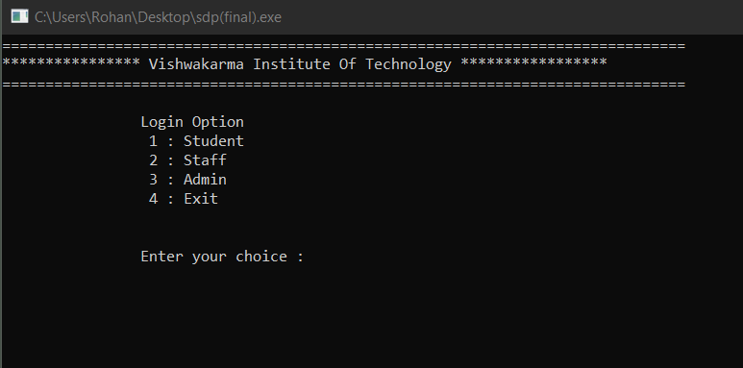

1)STUDENT MODULE:– This module used to see understudy profile ,understudies can see their participation, see their imprints see notices given by the workforce or head or anything like when school begins or the test dates. Understudy can likewise give whine about any issue related querry and difficulties they wanna report to the College.

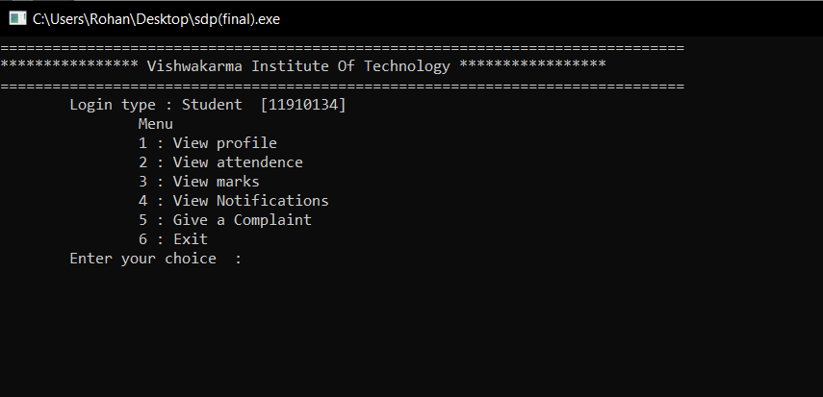
2) STAFF MODULE:- The staff can update the information regarding the student's attendance, internal marks of the students and any information regarding the subjects they handle. They can also view the student details for better understanding the student performance and improve the efficiency of the student.
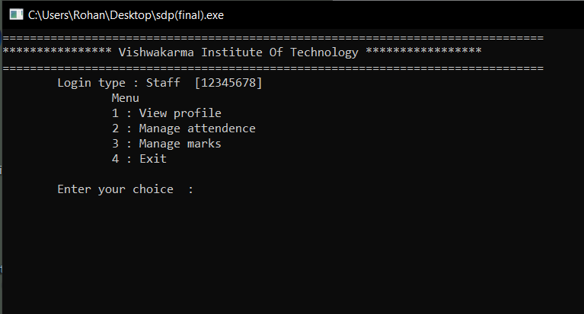
3) Admin:- This is the main module that has to be managed by the HOD of the Computer department. Here the admin can admit new students, remove any if they have left the college or anything, add and remove the staff members .Next he can see the list of students manage their attendance view marks send notifications it will be like the notice section of the college in which the College activities, Exam dates and any other important message can be share by the students and also check complains sent by the students so action can be taken in time.
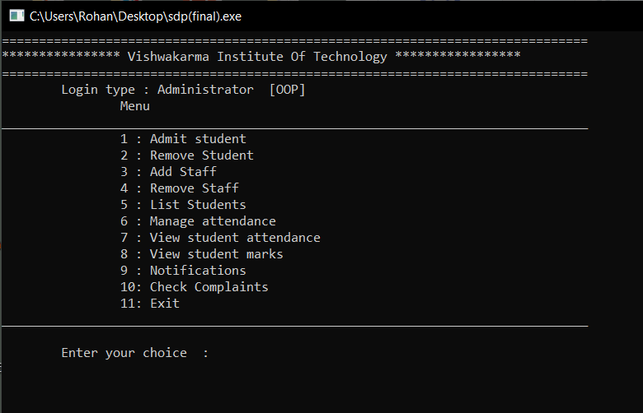

CONCLUSION AND FUTURE SCOPE
This gateway is utilized by the administrator so there is no information spillage and it can took care of safely. Conveying such a product to the division it assists with occurring task effortlessly and that is the reason it diminishes time ,cash on labor and endeavors. we have occasion module through which understudies to get the notification of impending occasions. What's more, understudies can give criticism about happened occasions in the office. Understudies can choose GS,LR,CR in the democratic module. It is an open source application with the goal that others can alter and change this framework application as per their requirements can be a future improvement in task.

www.udditportfolio.online
www.udditaimlblogs.online
GITHUB : UDDITwork
- References
[1] Kartiki Datakar, “Online College Management System”, International Journal of Computer Science and Mobile Computing, Vol. 5, Issue 4, April 2016.
[2] Lalit Joshi, “A Research Paper on College Management System”, International Journal of Computer Applications, Vol.122, Issue 11, July 2015.
[3] Mary Jane Magno-Tan, “Cloud-Based College Management System for Universities”, International Journal of Information and Education Technology, Vol.4, Issue 6, December 2014.
[4] S. R. Bharamagoudar, “Web-Based Student Information Management System”, International Journal of Advanced Research in Computer and Communication Engineering, Vol.2, Issue 6, June 2013.
[5] Srikant Patnaik, “College Management System”, International Research Journal of Engineering and Technology, Vol.3, Issue 5, May-2016
[6] Vishwakarma R. Ganesh, “Android College Management System”, International Journal of Advanced Research in Computer Engineering and Technology, Vol.5, Issue 4, April 2016.
[7]Lalit Mohan Joshi M.tech schola BTKIT Dwarahat, Almora, Uttarakhand “A Research Paper on College Management System” International Journal of Computer Applications (0975 – 8887) Volume 122 – No.11, July 2015

BIOGRAPHY

 “UDDIT”
Pursuing Btech in Metallurgy from MNIT Jaipur
2021UMT1791
Jaipur, India

